The First Walkthrough

1. Using the Wunderground API you did before, get the “feels like” centigrade and farenheit temperatures for Boston:

http://api.wunderground.com/api/***yourkey***/conditions/q/MA/Boston.json

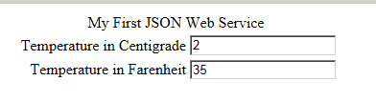

1. Using the Wunderground API, get the date and high temperature for the next several days  
   http://api.wunderground.com/api/yourkey/forecast/q/MA/Boston.json'

